Apply Now to Make it Happen!
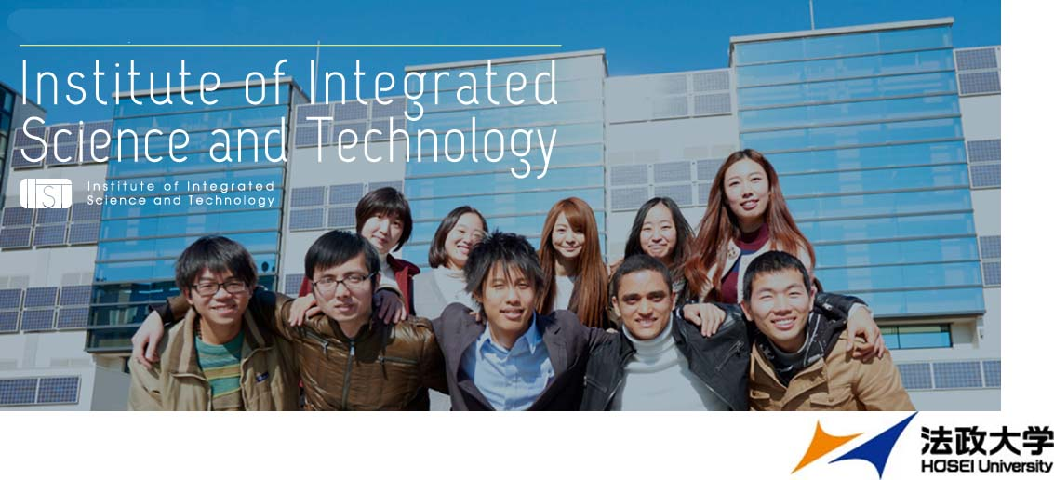
Invitation to Hosei University English based Graduate Program
IIST (Institute of Integrated Science and Technology)

WHO SHOULD APPLY
If you are graduating from a university majoring in science and/or engineering, and planning to continue your graduate study in Japan. Hosei University Institute of Integrated Science and Technology (IIST) is the best choice. Hosei University is one of the oldest and finest universities in Japan, selected as a MEXT Top Global University Project member. University lecturers looking for the opportunity to earn a doctoral degree are also welcome to enroll.
AREAS OF STUDY
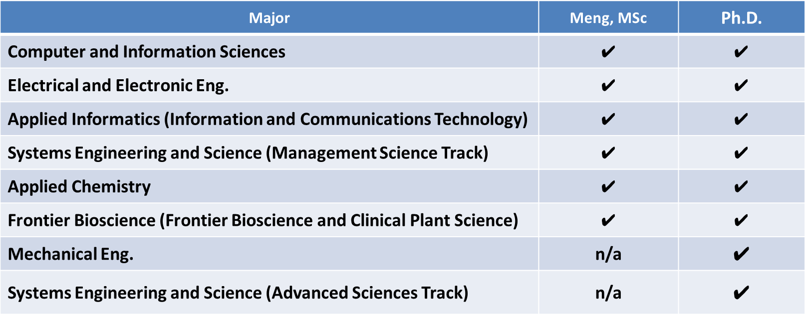
Research fields for the master’s program include Global Information Systems Development, Internet Security, IoT System Development, Ubiquitous Communication Systems, Information and Communications Technology, Media and Information Processing, Global Business Analysis/Planning, Finance Engineering, and Medical/Health Care Systems. The doctoral program includes wider research fields including Mechanical Engineering and Biotechnology/ Clinical Plant Science.
EDUCATIONAL GOAL AND CURRICULUM
The goal of IIST is to foster world-class scientists and professional engineers. With the optional Japanese reinforcement program, students can also acquire Japanese technical communication skills which strengthen their career development. Each IIST student will belong to one of 8 study majors listed in the previous section. IIST provides a comprehensive learning environment which enables students to take interdisciplinary classes depending on the nature of their study. From the first year, a supervising professor will be assigned to each student to personally guide the student’s research.

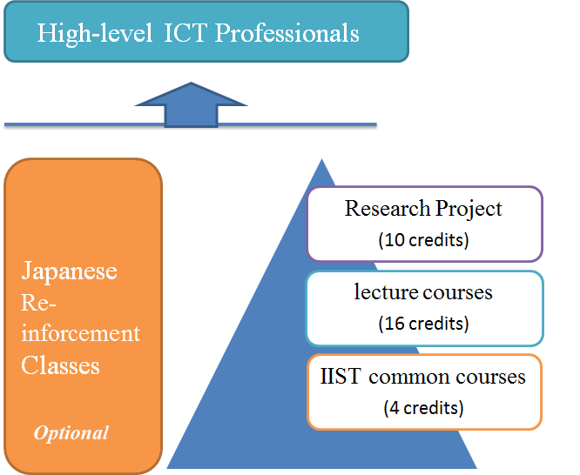HOW TO APPLY
First, please send an e-mail to hge@hosei.ac.jp describing your educational background and research interest/plan. IIST will put you in contact with the best suited research supervisor to develop the research plan with you. Candidates will be chosen based on the submitted final research plan and the applicant’s English proficiency. IELTS 5.5 or the equivalent score of TOEIC 680 or TOEFL iBT72 is required. Official English test score submission is not necessary for special affiliated university students with their institution’s recommendation.
Act now for Sept. 2018 enrollment.

TUITION AND SCHOLARSHIP
 | Master’s Course (JPY) | Doctoral Course (JPY)
Admission Fee | 200,000 | 200,000
Tuition (annual) | 880,000 | 600,000
Facility Fee (annual) | 100,000 | 100,000
Laboratory Fee (annual)*1 | 80,000 | 80,000
Amount to be paid at enrollment | 730,000 | 590,000
Amount to be paid at 2nd semester | 530,000 | 390,000
Notes: *1. Laboratory fee for Frontier Bioscience (Clinical Plant Science) is 140,000 yen., 2. Admission Fee is not refundable.
Doctoral students will receive an annual research grant of 300,000 JPY for three years. For both master’s and doctoral self-funded students, Hosei university has tuition reduction system. In previous years the reductions were approximately 20% of the annual tuition fees. In addition, IIST will provide part-time work opportunities such as Teaching Assistant (TA): 4,200 JPY/90min, Research Assistant (RA): 2,000 JPY/60min, or Tutor for international students: 4,200 JPY/90min. Students are also encouraged to apply for scholarships such as the MEXT scholarship for Privately-Financed International Students: 48,000 JPY/mon (www.jasso.go.jp/en/ ) or the Scholarship for Self-Supporting Students funded by Sato Yo International Scholarship Foundation: 180,000 JPY/mon (http://sisf.or.jp/en/ ).

MEXT: Japanese Ministry of Education, Culture, Sports, Science and Technology
http://www.hosei.ac.jp/english/campus/tuition/scholarship/

